Setting Up Amazon SageMaker Studio: A Hands-On Guide

Welcome Back!
In this lesson, we’ll take a hands-on approach to setting up Amazon SageMaker Studio. By the end of this session, you will have a fully functional SageMaker environment ready for developing and experimenting with machine learning projects.

Learning Objectives
In this hands-on exercise, you will learn how to:
- Create an Amazon SageMaker Domain
- Create and configure a user profile
- Assign permissions and IAM roles
- Launch and validate SageMaker Studio
- Create and run a JupyterLab workspace
- Understand the differences between SageMaker Studio and Studio Classic

Step 1: Access Amazon SageMaker
Begin by logging in to your AWS Management Console and navigate to Amazon SageMaker.
Amazon SageMaker is AWS’s fully managed machine learning service designed for:
- Building machine learning models
- Training models at scale
- Deploying models into production environments quickly and efficiently
SageMaker provides one of the fastest ways to move from experimentation to production-ready machine learning solutions.

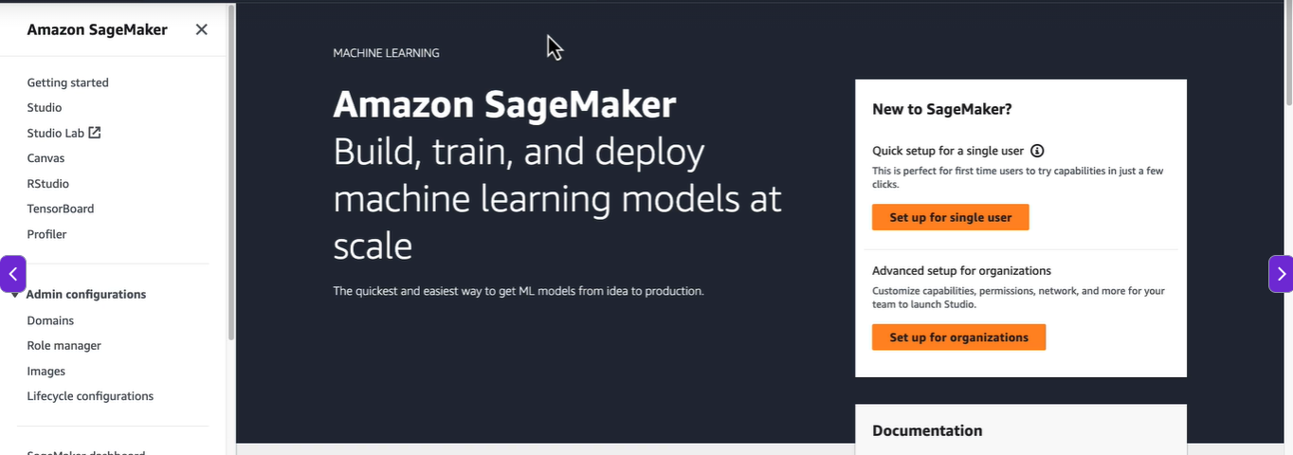

Step 2: Create a SageMaker Domain
Before using SageMaker Studio, you must first create a SageMaker Domain.
Navigate to:
Amazon SageMaker → Domains → Create Domain
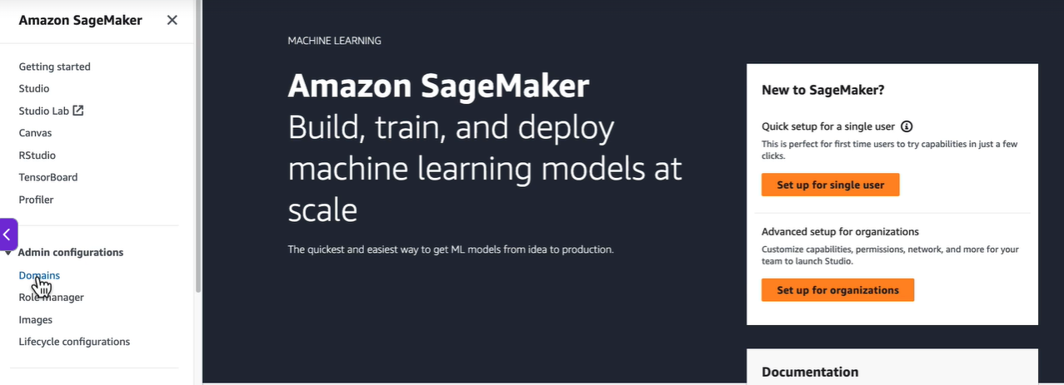

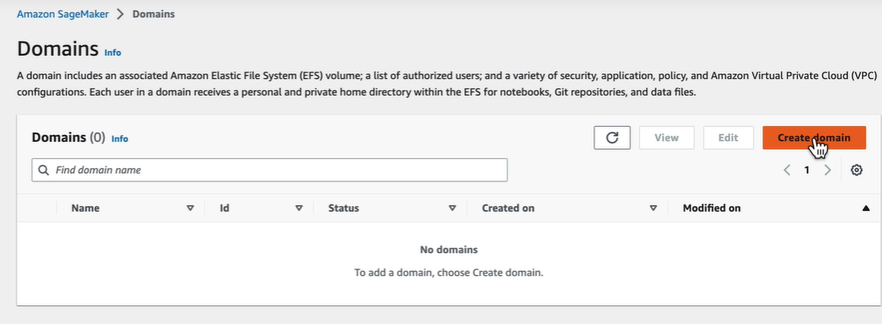
During setup, AWS provides two configuration options:

Option 1: Single User Setup
Designed for individual learners and developers.

Option 2: Organization Setup
Designed for teams and enterprise environments with multiple users.
For learning purposes, we’ll choose:
Setup for a Single User
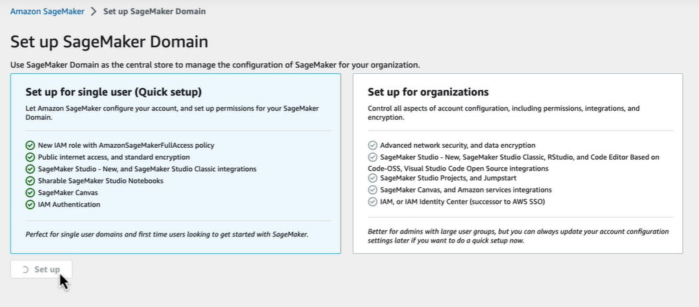

What Does the Quick Setup Create?
The single-user setup automatically provisions several resources:
- An IAM role with SageMaker Full Access permissions
- Public internet access
- Standard encryption settings
- SageMaker Studio environment
- Shareable notebooks
- SageMaker Canvas
- IAM-based authentication
This automated setup significantly reduces the time required to configure the environment manually.
Note: Domain creation typically takes between 5 to 10 minutes. Wait until the domain status changes from Pending to In Service.

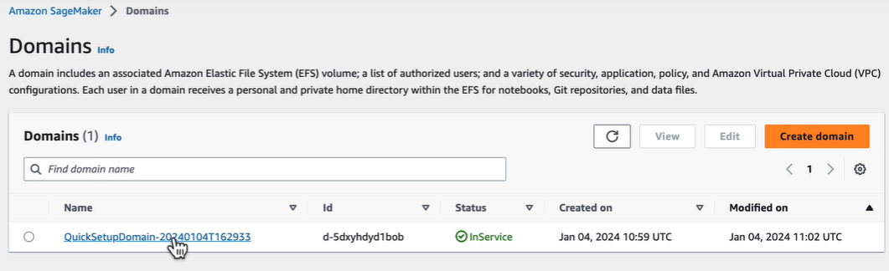

Step 3: Create a User Profile
After the domain is successfully created, launch it.
In most cases, SageMaker automatically creates a default user profile. If it doesn’t, you can create one manually.
Click:
Add User
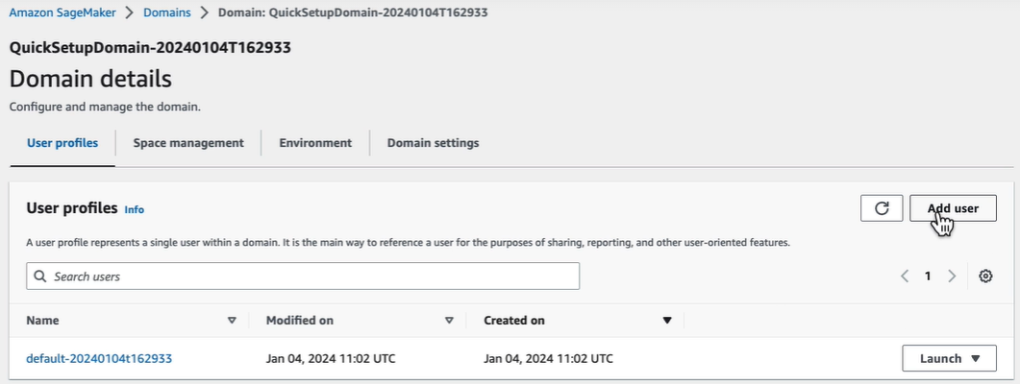
Provide:
- User Profile Name (for example: mlops-user)
- Execution Role
You can either:
- Use the default execution role
- Create a new IAM role with custom permissions
If creating a new role, SageMaker allows you to specify:
- Access to specific Amazon S3 buckets
- Permissions required for your machine learning workloads
After configuring the settings, proceed through the remaining steps and click Submit.
Note: User profile creation may take a few minutes.

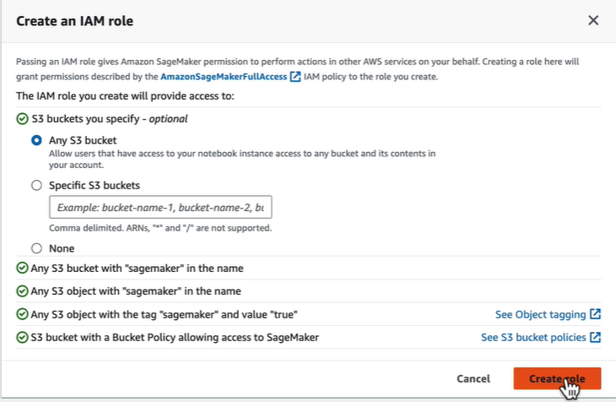
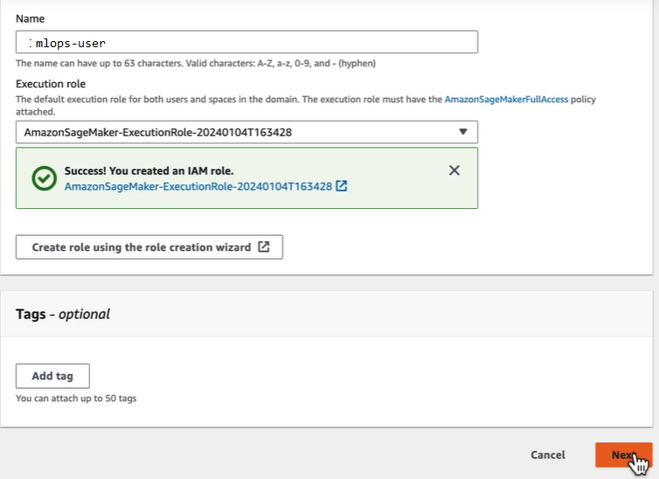
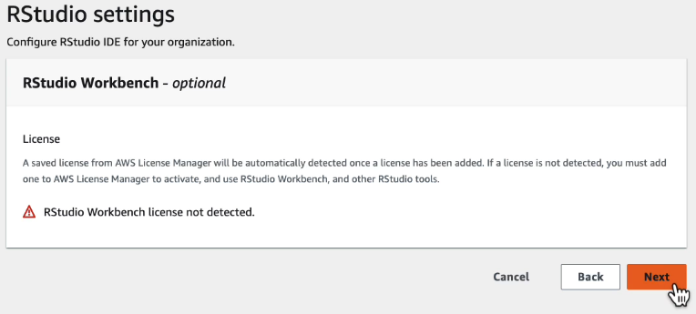

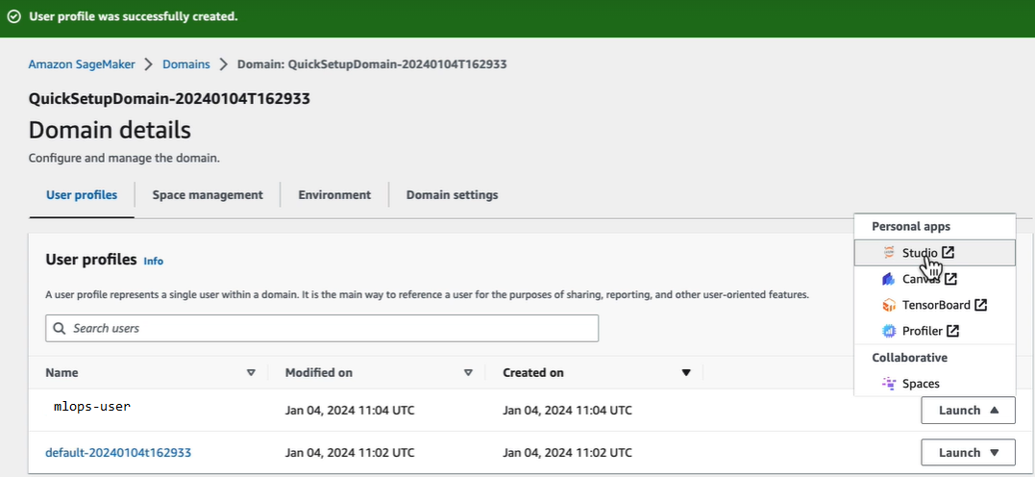

Step 4: Launch SageMaker Studio
Once the user profile is ready:
Launch → SageMaker Studio
Amazon SageMaker Studio serves as a unified development environment for machine learning.
The interface provides access to:
- JupyterLab
- SageMaker Canvas
- Code Editor
- SageMaker Studio Classic

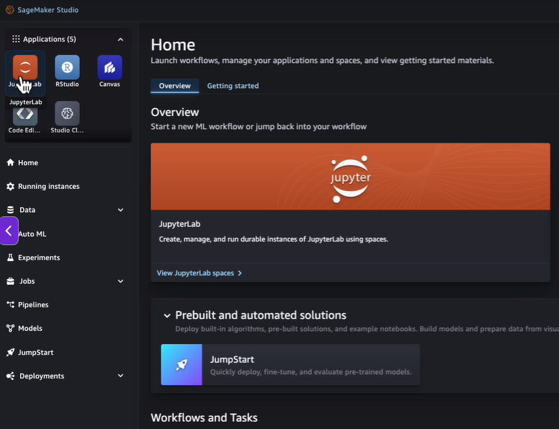

Step 5: Create a JupyterLab Workspace
Most machine learning development activities begin within Jupyter notebooks.
To create a workspace:
- Open JupyterLab
- Click Create JupyterLab Space

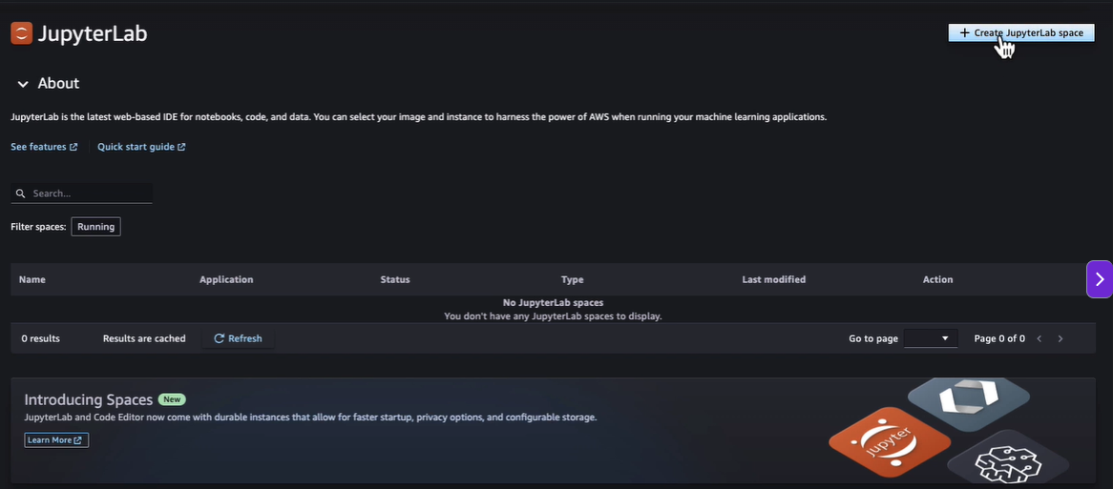
- Enter a name for the workspace

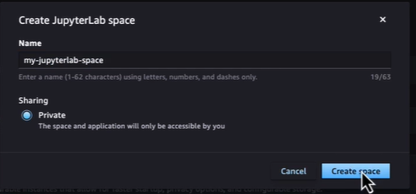
- Select the notebook instance configuration
By default, SageMaker recommends:
- Instance Type: ml.t3.medium
- Latest SageMaker Distribution Image
- Storage: 5 GB
Click:
Run Space
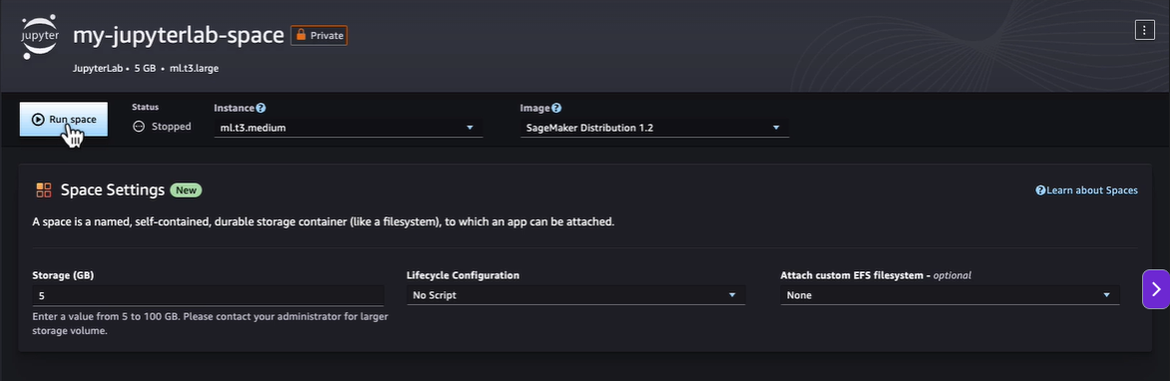
SageMaker provisions the compute environment and prepares the notebook workspace.

Understanding the JupyterLab Environment
Once the space is running, click Open.
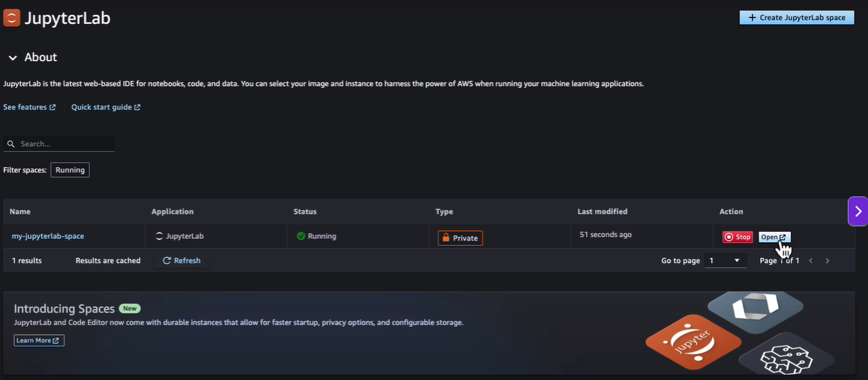
The JupyterLab interface is very similar to a locally installed Jupyter environment. The primary difference is that the underlying compute infrastructure is managed entirely by AWS.
You can:
- Create notebooks
- Rename notebooks
- Write and execute Python code
- Upload existing notebooks
- Manage files and datasets

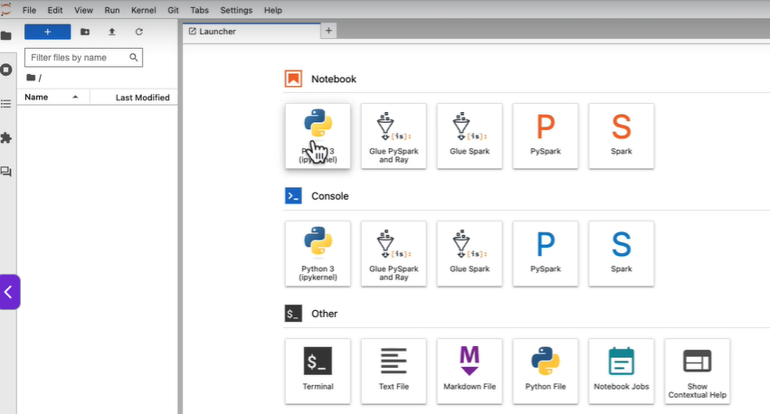
For example:
print("Hello World")
Executing the cell immediately displays the output, just like any standard Jupyter notebook.
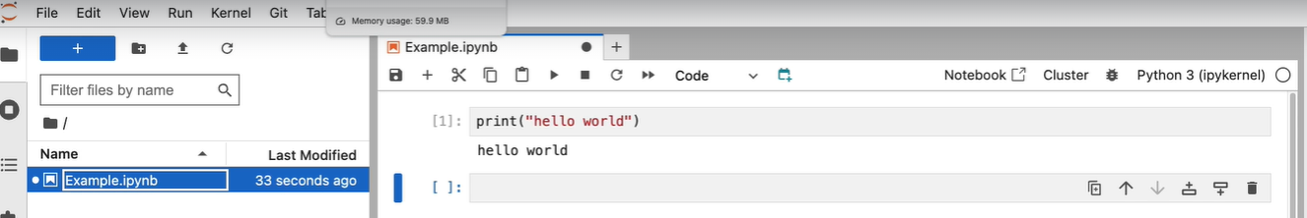

Uploading Existing Projects
SageMaker also allows you to upload pre-built notebooks and scripts directly from your local system.
Simply:
- Click the Upload button
- Select your notebook file (.ipynb)
- Open and execute the notebook
This feature enables you to quickly migrate existing projects into the SageMaker environment.

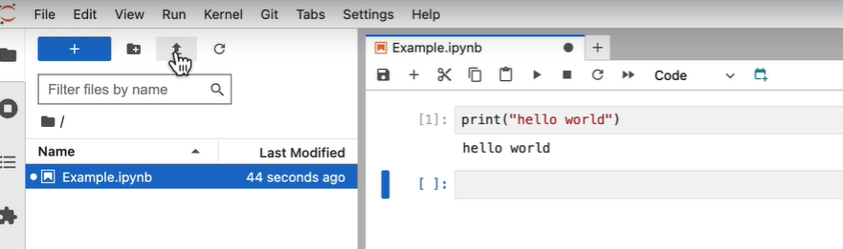

Exploring SageMaker Studio Features
Beyond notebooks, SageMaker Studio offers numerous capabilities for end-to-end machine learning workflows.

Data Management
- Data Wrangler
- Feature Store
- EMR Clusters
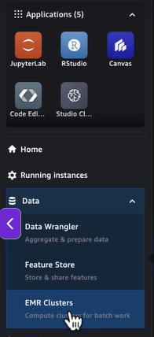

Machine Learning Automation
- AutoML
- SageMaker Experiments
- Training Jobs
- Evaluation Jobs

MLOps and Deployment
- SageMaker Pipelines
- Model Management
- Endpoint Deployment
- Real-time Inference Management
As we progress through this learning journey, we’ll explore each of these services in greater detail.

Introducing SageMaker Studio Classic
AWS also provides SageMaker Studio Classic, the earlier version of the SageMaker interface.
To launch it:
SageMaker Studio Classic → Create Space → Run Space
Studio Classic also allows you to:
- Create notebooks
- Select kernels and images
- Choose instance types
- Build and train machine learning models
Functionally, both Studio and Studio Classic offer similar capabilities.
The primary difference lies in the user interface and overall user experience.

Summary
In this hands-on session, you learned how to:
✅ Create a SageMaker Domain
✅ Configure user profiles and permissions
✅ Launch Amazon SageMaker Studio
✅ Create and run JupyterLab workspaces
✅ Work with notebooks in SageMaker
✅ Upload existing projects and code
✅ Explore built-in MLOps and deployment capabilities
✅ Understand SageMaker Studio Classic
You now have a fully configured SageMaker environment and are ready to begin building, training, and deploying machine learning solutions on AWS.
In the next lesson, we’ll continue our journey by exploring additional SageMaker features and working with practical machine learning workflows.

